**FOR IMMEDIATE RELEASE**

**WINS (Women In Need Society) Celebrates More Store’s Second Anniversary**

*After two years in business, WINS’ More Store contributes revenues to vital program operations, while reducing landfill waste*

**CALGARY, JUNE 9, 2022 –** WINS (Women In Need Society) is celebrating the second anniversary of the [More Store](https://www.winsyyc.ca/more-store). An extension of WINS’ existing thrift store enterprise offering a wide variety of gently-used clothing at discounted prices, the unique bin-style thrift store offers every item for one dollar or less. The first of its kind in Calgary and located at Unit 141 7007 54 St SE, the More Store offers bulk pricing, meaning the more customers purchase, the lower the price.

Launched in June of 2020, the More Store provides one last chance for donated items to find a new home. In two years of operations, the More Store’s revenues are already helping support ten vital WINS programs, including [House to Home](https://www.winsyyc.ca/house-to-home-by-wins), [Retail Ready](https://www.winsyyc.ca/retail-ready-by-wins) and [Warehouse Ready](https://www.winsyyc.ca/warehouse-ready-by-wins). In 2021, WINS provided 22,255 services to more than 14,000 Calgarians and diverted 4.1 million pounds of clothing, household items and furniture from Calgary landfills.

“When Calgarians needed extra support during the pandemic, WINS was there with programs, services and social enterprises to ensure our work in the community,” says Karen Ramchuk, President and CEO of WINS. “Although many of us have seen life return to normal, the effects of the pandemic continue to impact Calgarians. While our operations have grown, the needs in our community have grown as well. The More Store is just one of the ways WINS is directly helping Calgary women and their families move from surviving to thriving.”

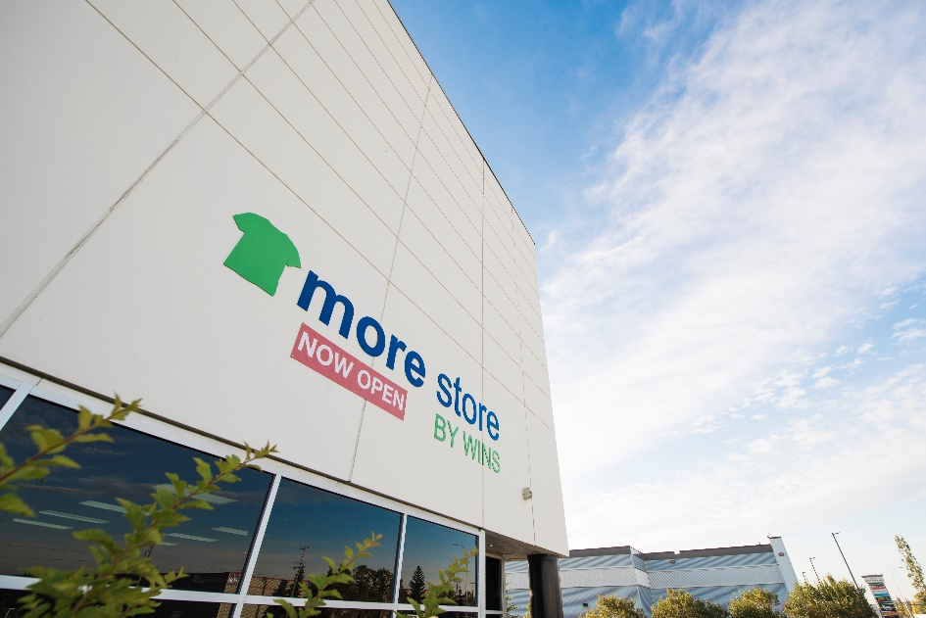

*Launched in June of 2020, the unique bin-style thrift store offers every item for one dollar or less (Courtesy of Mark Eleven Photography).*

Despite Calgary seeing [economic growth,](https://conferenceboard.ca/e-library/abstract.aspx?did=11618) [one in 10](https://enoughforall.ca/resources/poverty-affects-every-aspect-of-your-life-not-only) Calgarians continue to live below the poverty line. The More Store offers an affordable way for Calgarians in need to get essential clothing items for themselves and their families. WINS sees a variety of shoppers at the More Store, ranging from those who are low income to customers who are there simply for the love of thrifting.

This year also marks 30 years of WINS providing resources for Calgary women and their families to move from surviving to thriving. To celebrate, WINS launched a campaign to raise $30,000 from individual Calgarians by June 30. Calgarians are invited to be part of the change and help WINS help more women in need by donating to WINS on their [website](https://winsyyc.secure.force.com/Fundraising?id=a1a4x000003RefhAAC).

Starting with a single thrift store in 1992, WINS’ social enterprises have grown to include six thrift stores, four community resource hubs, two program centres and a bin thrift store, all located in Calgary. Revenues from the social enterprises fund the majority of WINS programs, which provide barrier-free access to help Calgary women and their families live better lives. During the COVID-19 pandemic, WINS also launched a nationwide online thrift shopping enterprise, [Twice New by WINS](https://twicenewbywins.ca/) which continues to revolutionize thrifting for Canadians and fund services in Calgary. To learn more, please visit [www.winsyyc.ca](http://winsyyc.ca).

-30-

**About WINS**

WINS (Women In Need Society) is a Calgary-based charity helping women in need and their families. WINS provides women with the resources, knowledge, skills and confidence to achieve self-sufficiency. Operating four Community Resource Hubs, House to Home, Retail Ready, Warehouse Ready, a Recycling Program and the WINS Thrift Stores social enterprise, including More Store and Twice New. For more information, please visit[www.winsyyc.ca](http://winsyyc.ca).

**Media Contact**

Paula Worthington, Worthington PR & Story

For WINS

403-585-2429

paula@worthingtonpr.com